Take the sample application nodejs and build it- > deploy to s3.

-take the application

-build application

-deploy the application to s3.

* First we should install nodejs
* After instaling the nodejs it will show the verisions

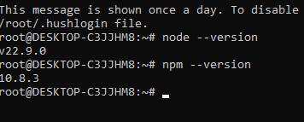

* Created a Nodejs Application
* Instalized a new Nodejs application by using npm init-y

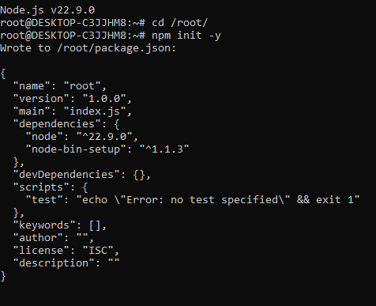

Created a sample node.js application file

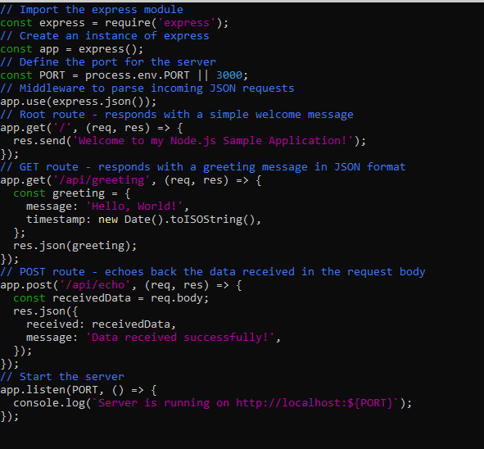

Output:

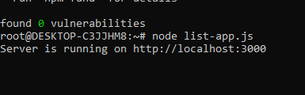

This output will show in google by using <http://localhost:3000>

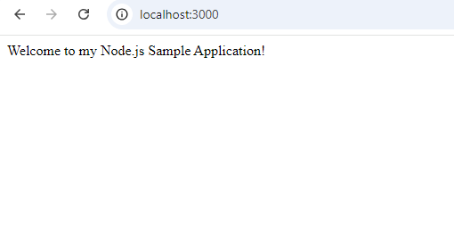

* Created a s3 buckect to upload file (“ZIP FILE”)

